**How to download noaa data (the best source) – We are using This!  \*\*\*\***

<https://www.google.com/url?sa=t&rct=j&q=&esrc=s&source=web&cd=&ved=2ahUKEwi5h-qBypH2AhXwj4kEHaq-CGMQFnoECAMQAw&url=https%3A%2F%2Fwww.ars.usda.gov%2FARSUserFiles%2F30980500%2FHowtoWeather2.docx&usg=AOvVaw2EgoOLVsgkGeDm2hTB6Ecu>

1. Go to <http://www.ncdc.noaa.gov/cdo-web/>
2. Click on the Search Tool.
3. Select Weather Observation Type/Dataset and select **Daily Summaries.**
4. Select Date Range using the calendar button (*Be sure to get daily weather data for 365/366 days of the year*).
5. Search for and choose the appropriate search type you will be using (typically we select **Stations).**
6. Enter a Search Term.
7. Click the **Search** button.

Now you should see a map of possible stations. You can navigate this just like Google Maps. Click on a square blue radio tower to see a summary of the station’s available data. The details show the **Latitude/Longitude** and the time **Period** they have weather data. Choose a site with as close to 100% **Coverage** to have the least amount of holes in your data. You can also click on the Full Details button or the station name on the left site of the screen to connect you to additional details of the station’s data.

1. Select a specific weather station by clicking on the orange **Add** or **Add to Cart** button depending on which method you used to find the station.
2. Click the orange **Cart** when you have added the station you want.
3. Review your Cart to make sure that the date range and stations name are what you selected.
4. Select the Output Format click on **Custom GHCN-Daily CSV.**
5. Click **Continue.**
6. Select the features you wish to receive.
7. Click **Continue.**
8. Enter email address and verify email address.
9. Click **Submit Order**.
10. You will receive an email saying that you requested data and another one saying the request is complete.
11. Click on the link at the top in the green box or the download data link, and save.
12. Open with EXCEL and format the data as shown below.

Step 8 Screen shot:

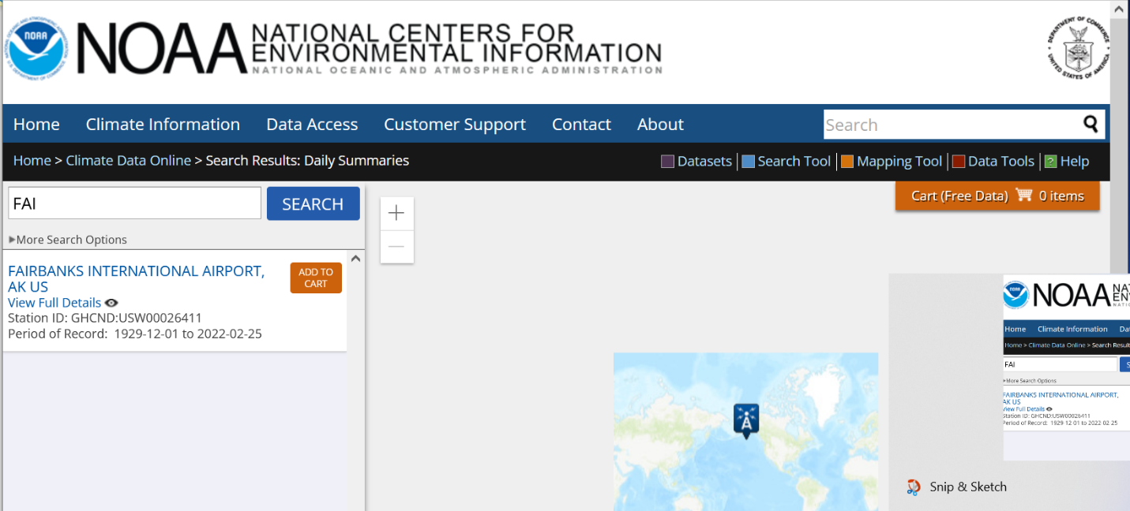[Text Wrapping Break]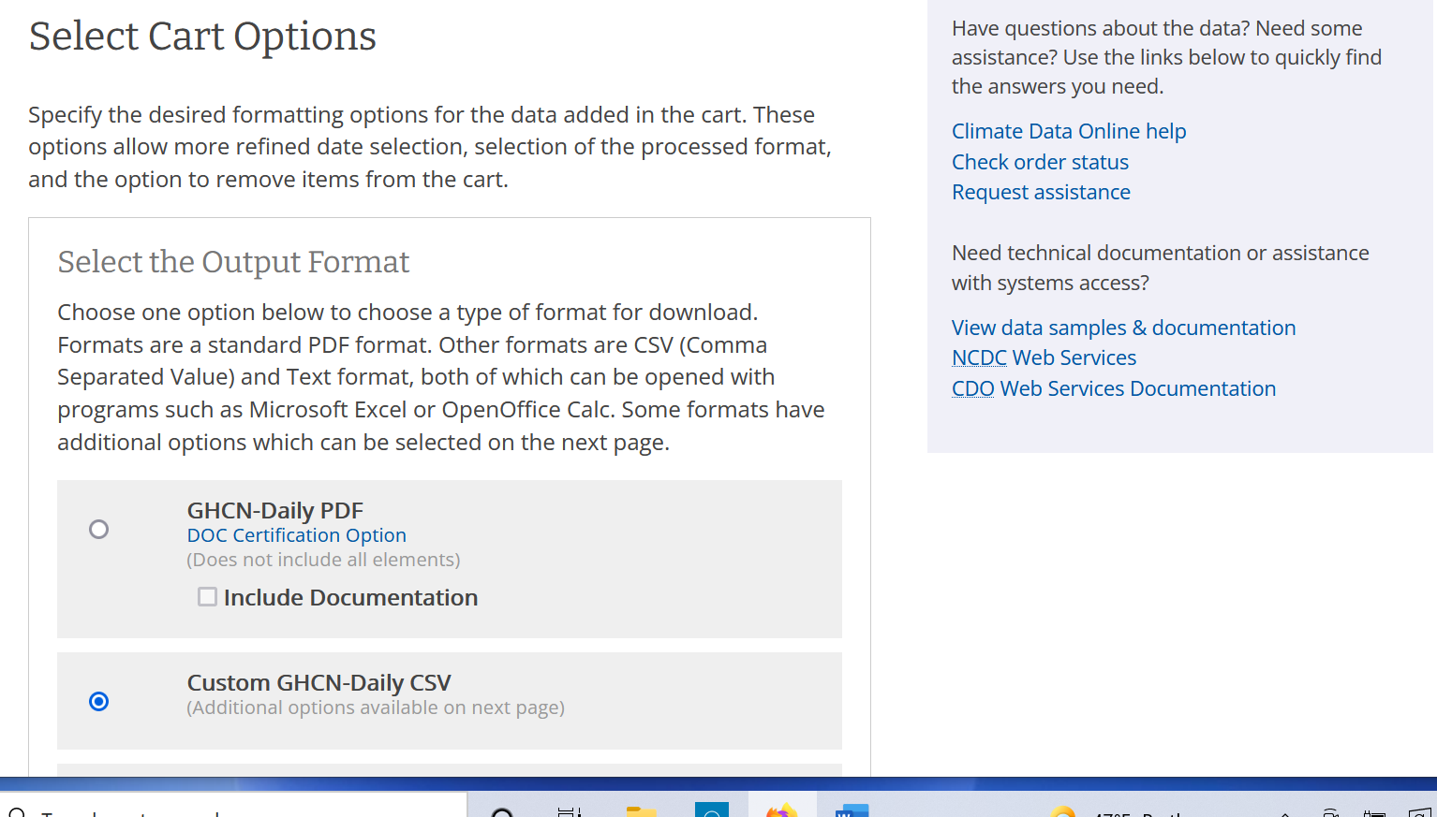

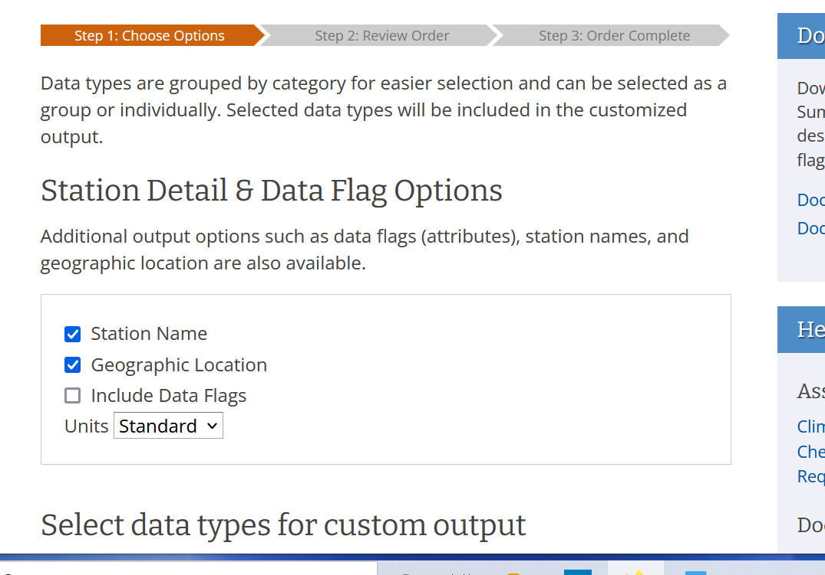

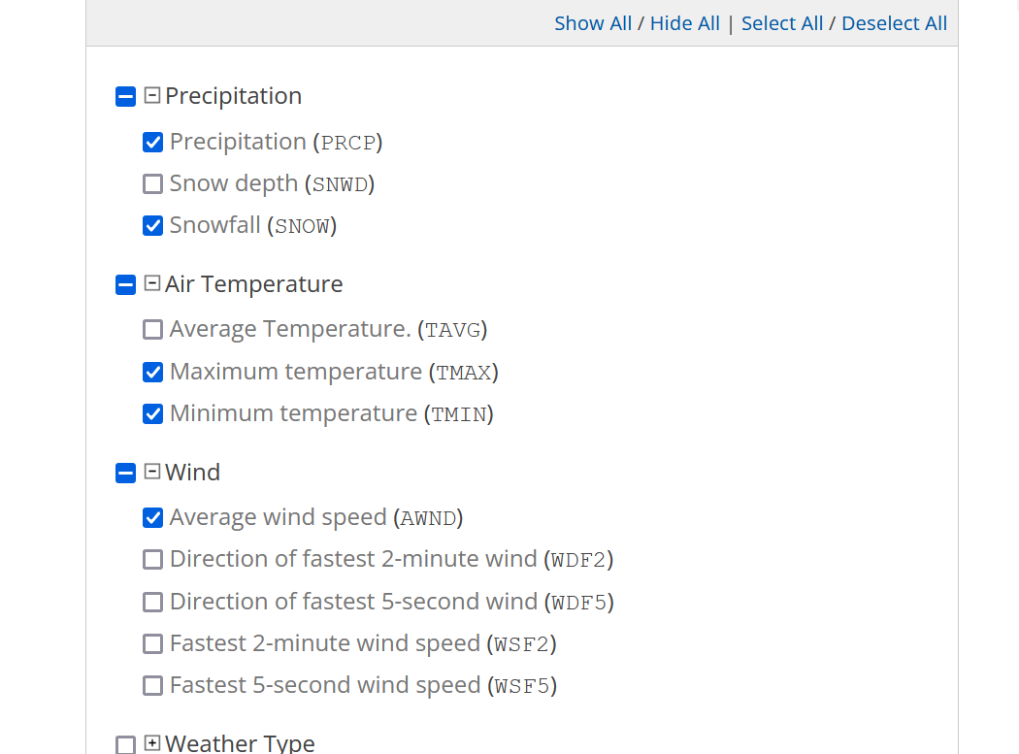

Top of Form

For noaa Daily Summaries Data set citation

[https://www.ncei.noaa.gov/metadata/geoportal/rest/metadata/item/gov.noaa.ncdc:C00861/html#](https://www.ncei.noaa.gov/metadata/geoportal/rest/metadata/item/gov.noaa.ncdc:C00861/html)

* Cite as: Menne, Matthew J., Imke Durre, Bryant Korzeniewski, Shelley McNeill, Kristy Thomas, Xungang Yin, Steven Anthony, Ron Ray, Russell S. Vose, Byron E.Gleason, and Tamara G. Houston (2012): Global Historical Climatology Network - Daily (GHCN-Daily), Version 3. [indicate subset used]. NOAA National Climatic Data Center. doi:10.7289/V5D21VHZ [access date].
* Publications citing this dataset should also cite the following article: Matthew J. Menne, Imke Durre, Russell S. Vose, Byron E. Gleason, and Tamara G. Houston, 2012: An Overview of the Global Historical Climatology Network-Daily Database. J. Atmos. Oceanic Technol., 29, 897-910. doi:10.1175/JTECH-D-11-00103.1.

**Procedure to download TowerOps data  -THIS IS WHAT WE ARE USING**

**See screen shots below and the link** <https://aspm.faa.gov>

<https://aspm.faa.gov>

This link below describes a report comparing CountOps and OPSNET Tower Comparison numbers to show how they were trying to validate the numbers

https://aspm.faa.gov/aspmhelp/index/CountOps__CountOps/OPSNET_Tower_Comparison_Report.html

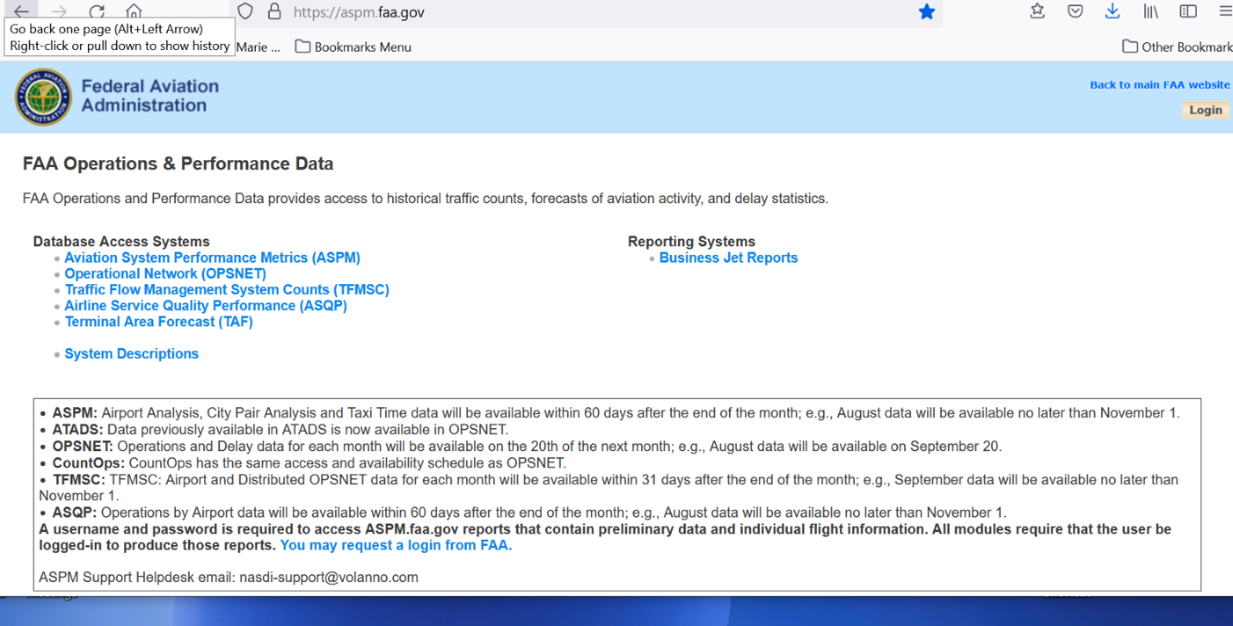

Choose OPSNET

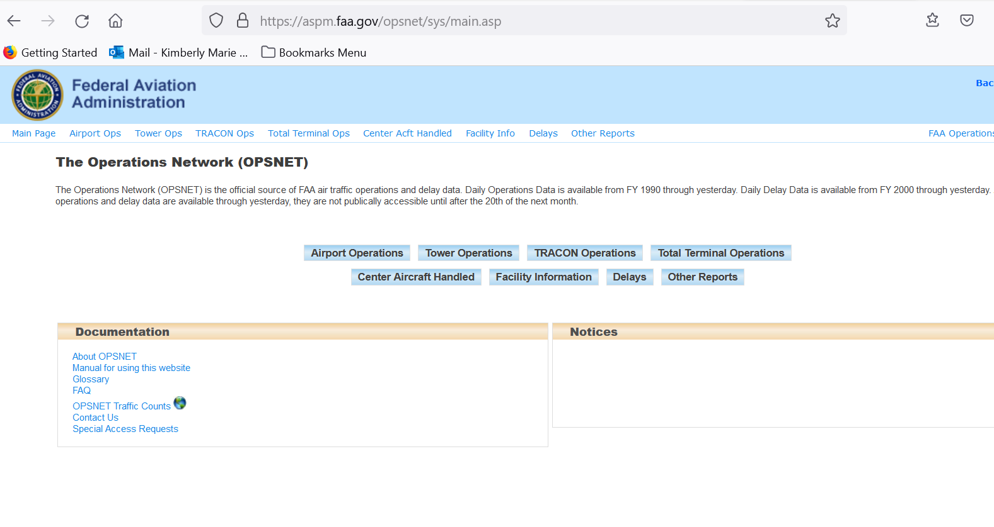

Choose tower Operations

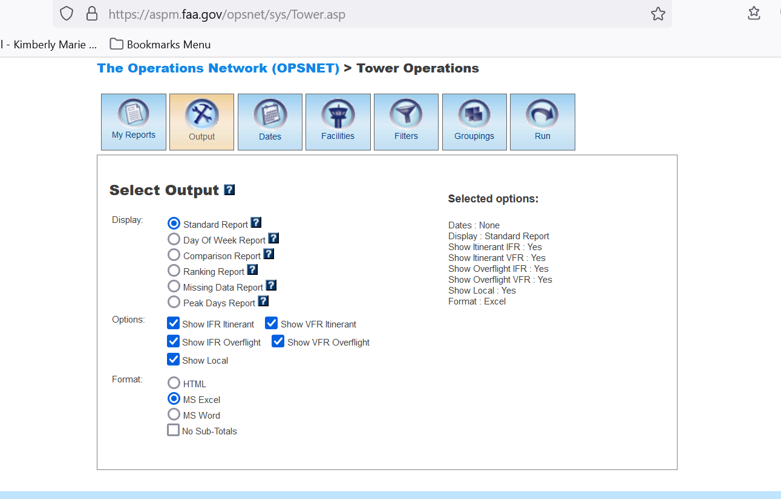

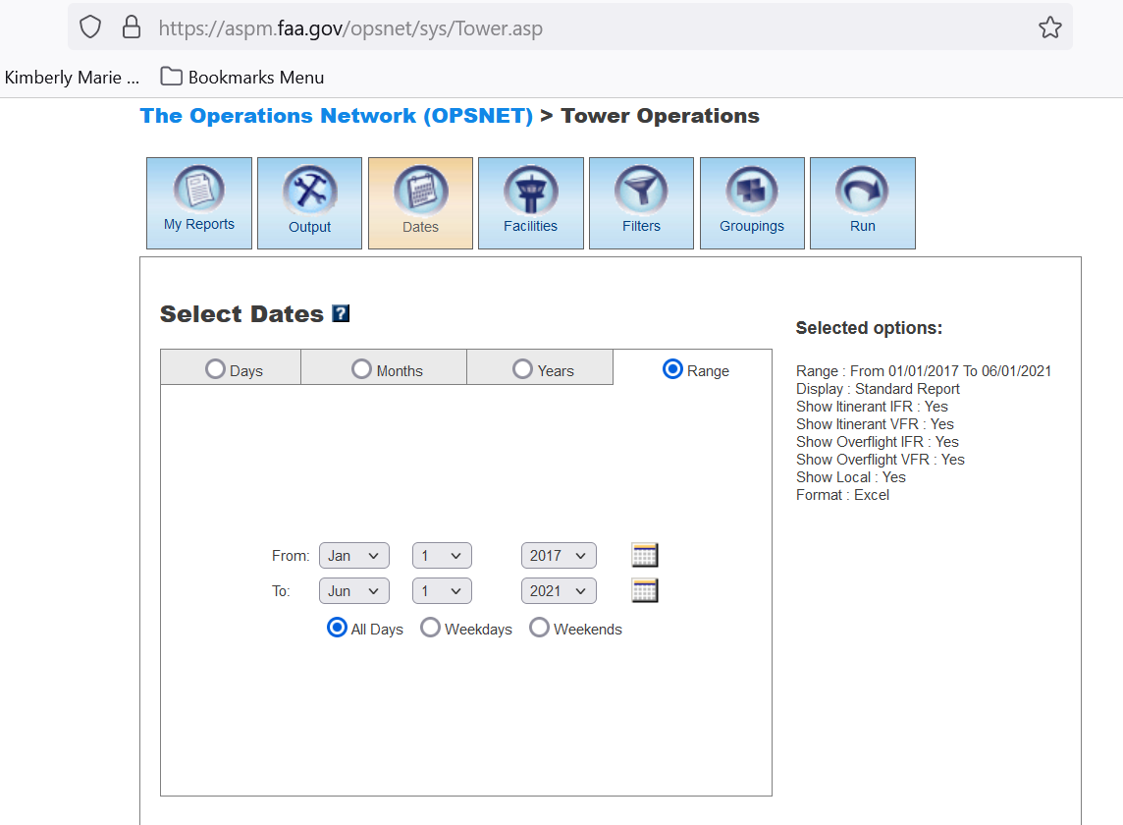

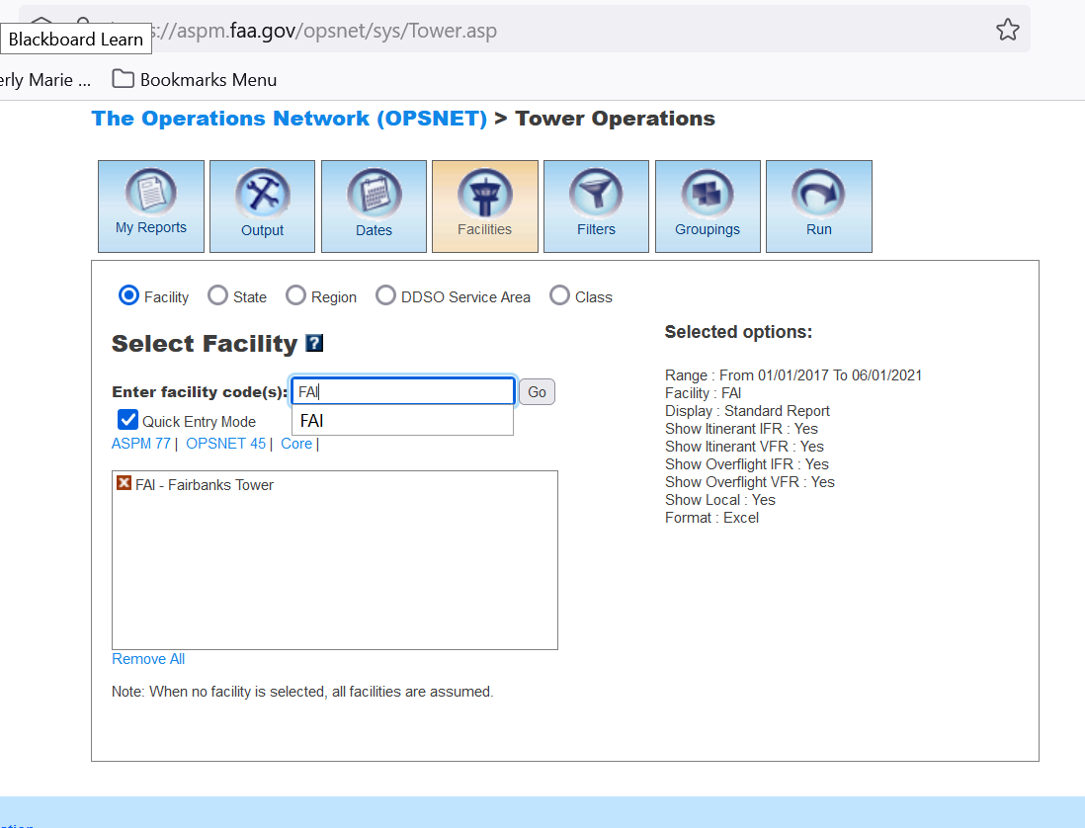

Enter Airport and click Go

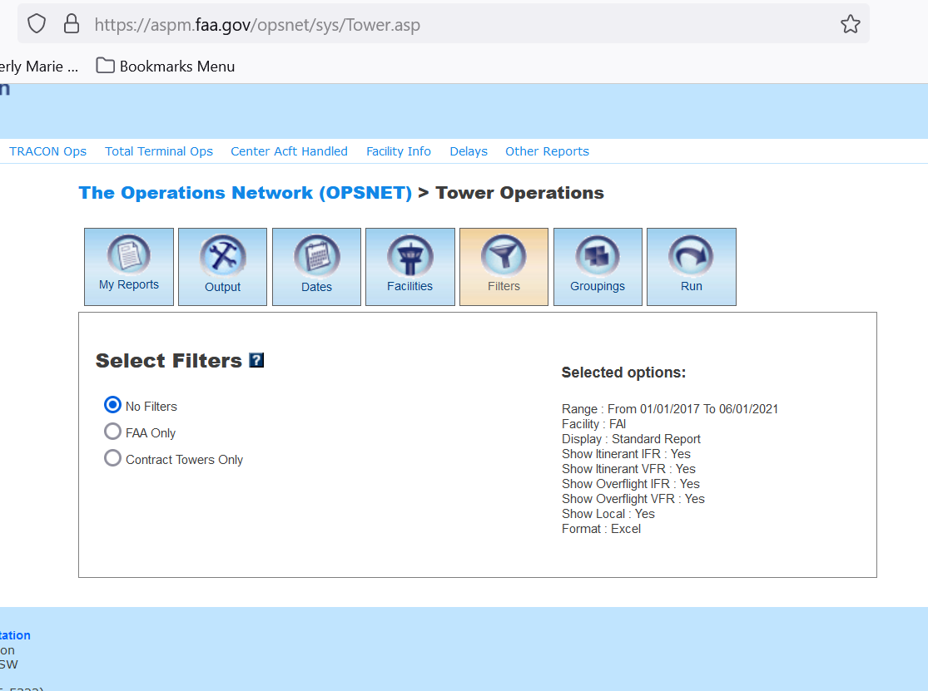

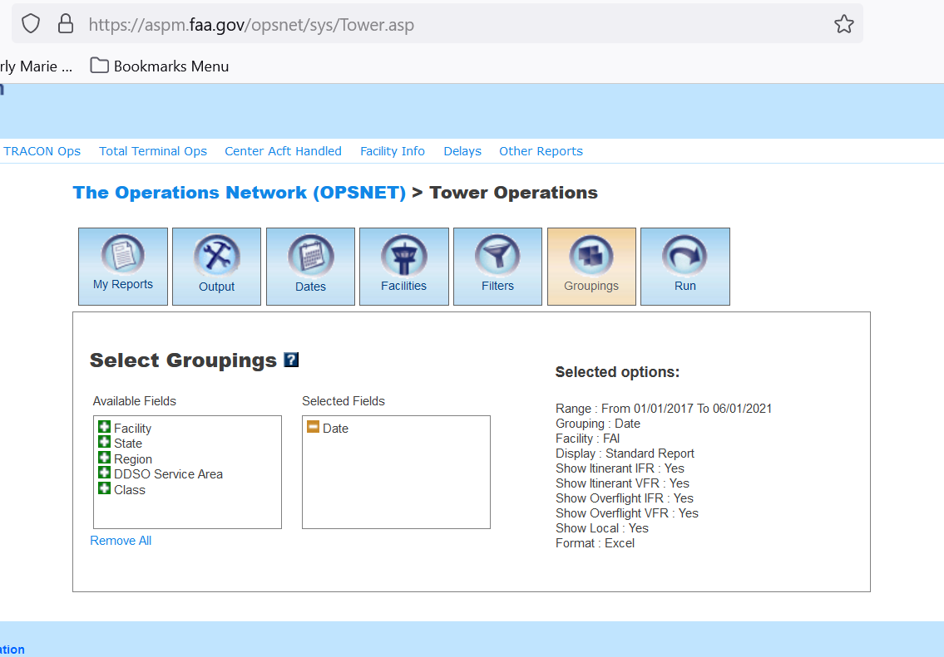

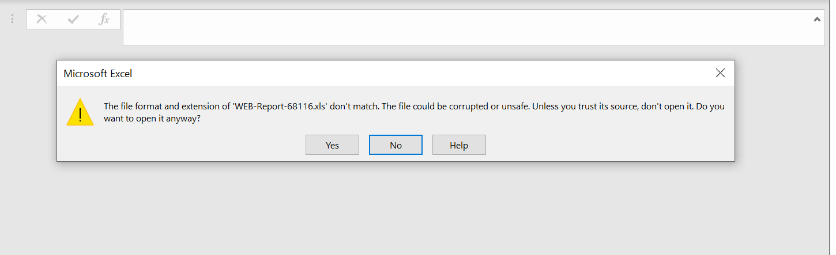

Say yes

**OPSNET Reports: Definitions of Variables**

<https://aspm.faa.gov/aspmhelp/index/OPSNET_Reports__Definitions_of_Variables.html>

**OPSNET Manual**

<https://aspm.faa.gov/aspmhelp/index/OPSNET_Manual.html#Definitions_of_Variables>

**Open Weather API**

**To Subscribe and get your API KEY**

<https://openweathermap.org/api>

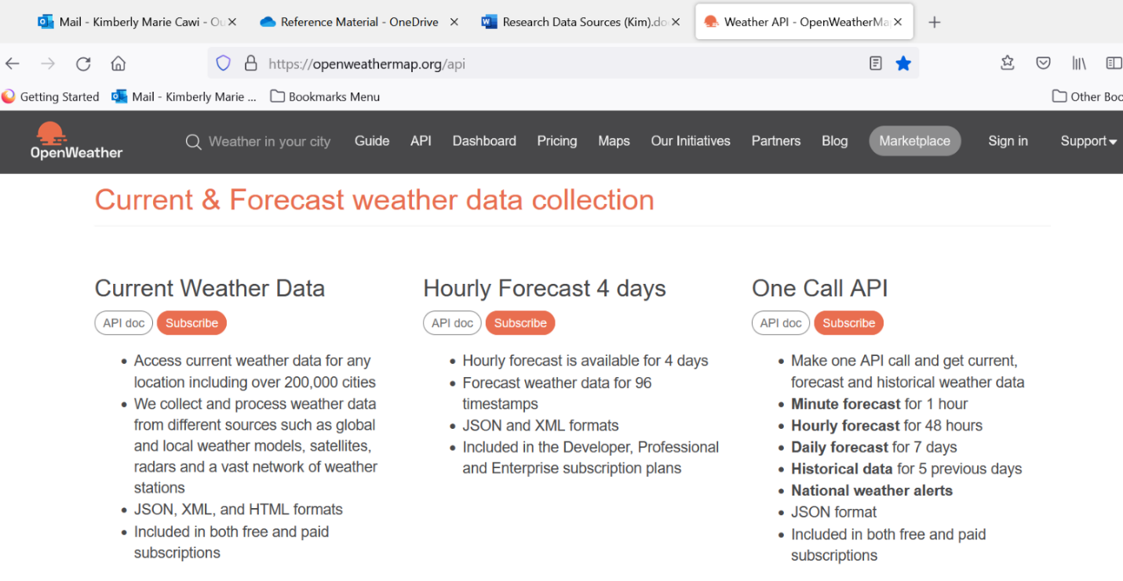

Click Subscribe under the One Call API:  takes you here <https://openweathermap.org/full-price#current>

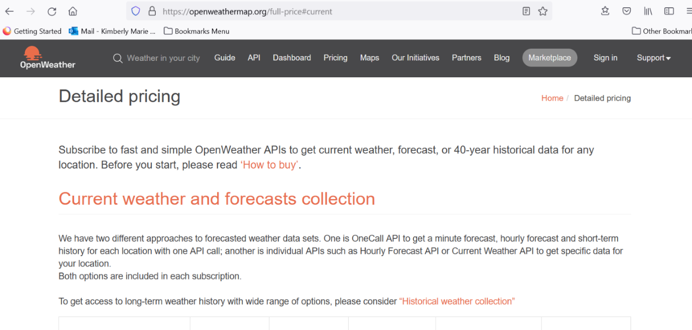

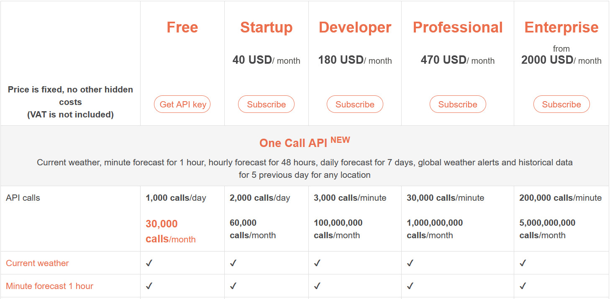

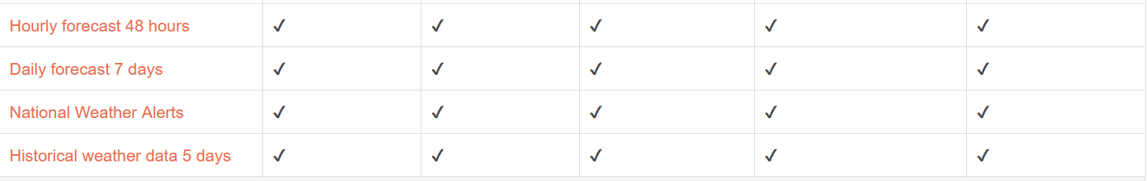

Click Get API Key from Free Column 1,000 calls per day and 30,000 calls per month

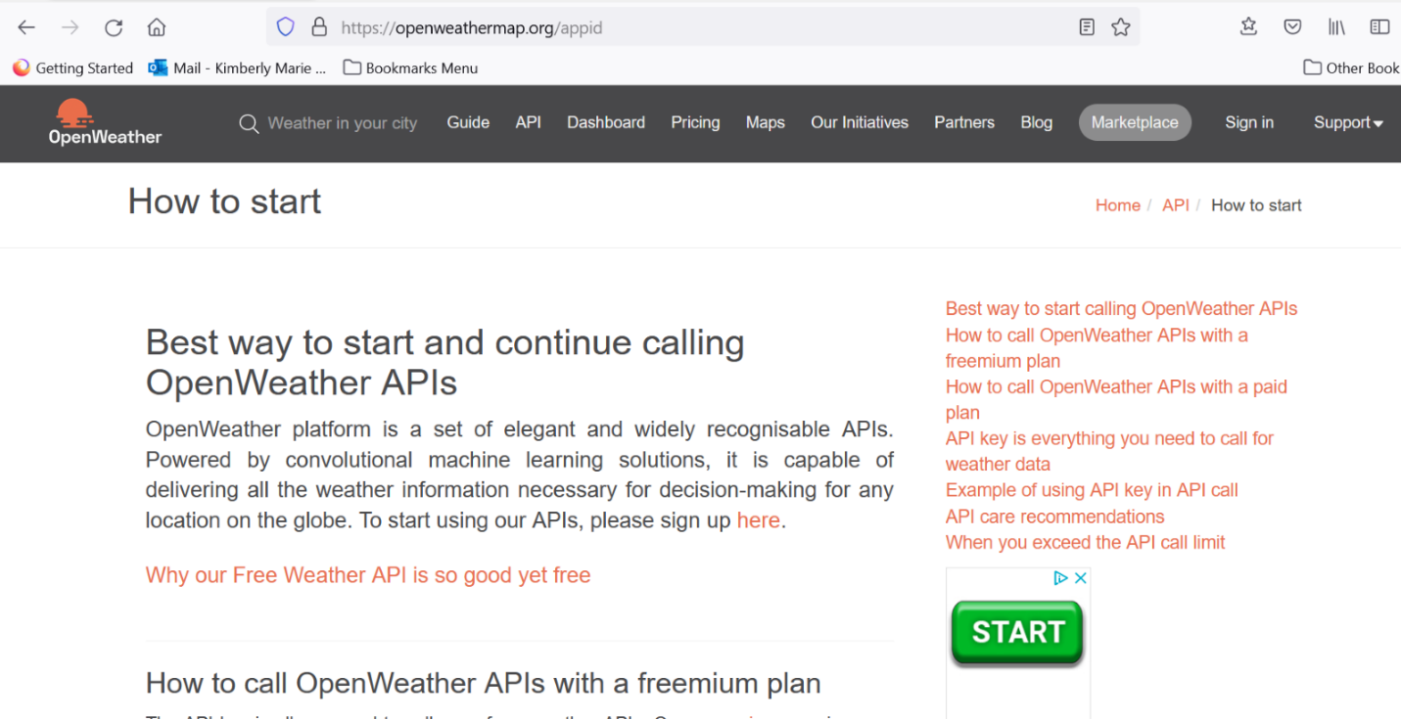

Click sign up here. Fill out form.

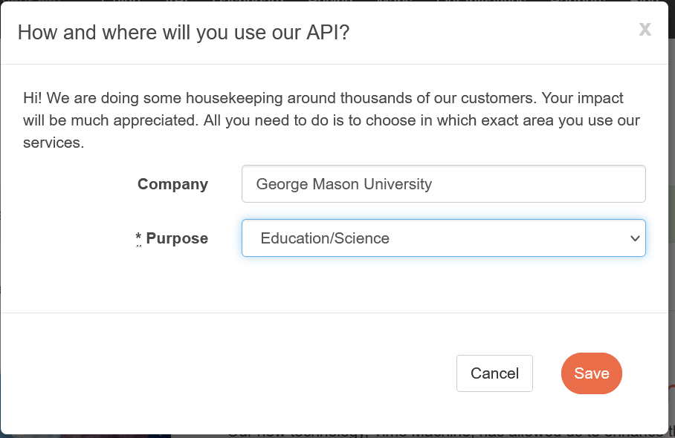

Click Save

**Main openweather site and general info**

[**https://openweathermap.org/**](https://openweathermap.org/)

<https://openweathermap.org/api/one-call-api>  ****  General Information

Note:  Good version of weather API.  Can get a 7 day forecast for free, 1,000 calls a day and 30,000 calls/mo, Response is in Json for free version.  Has Max temp and windspeed, but may or may not show precipitation amount or snowfall amounts depending on availability.  If not there, then value is 0. Does have probability of precipitation.  Most promising source.  Signed up for One Call for free.

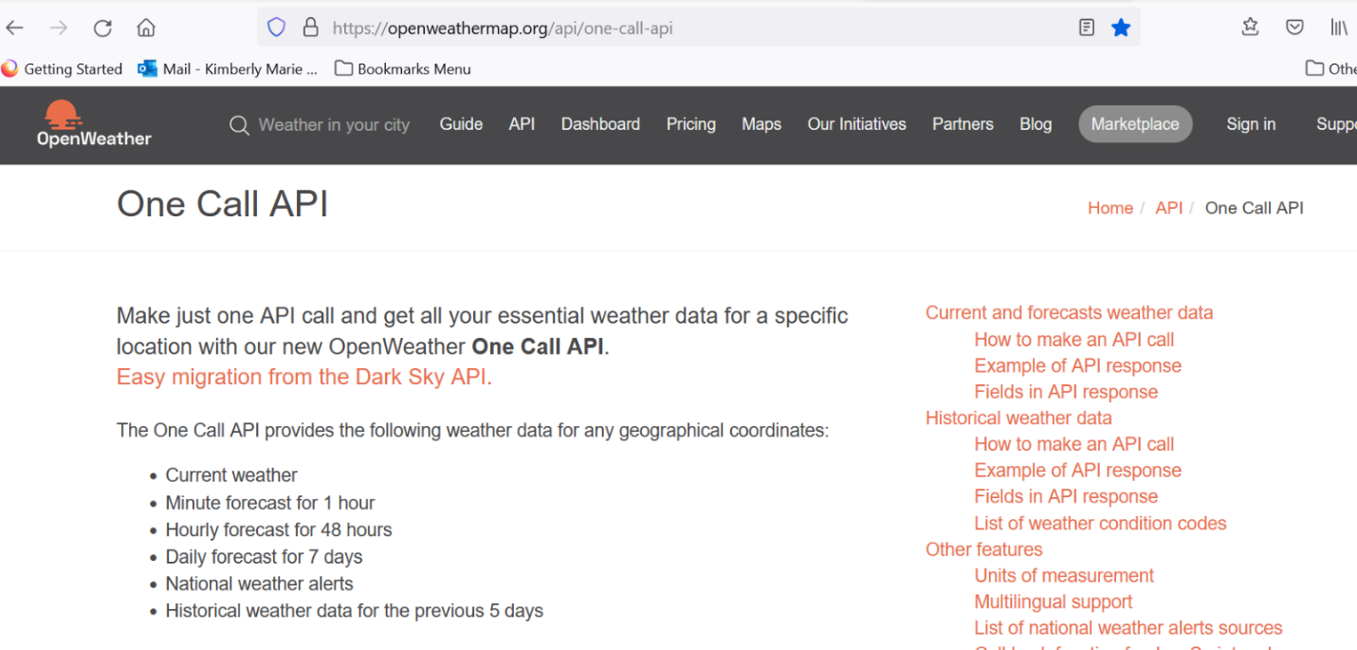

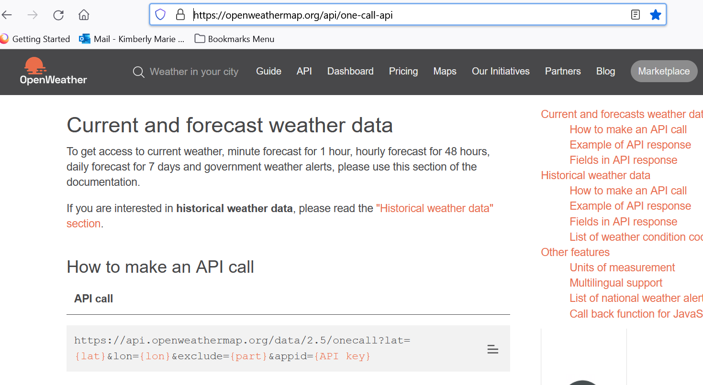

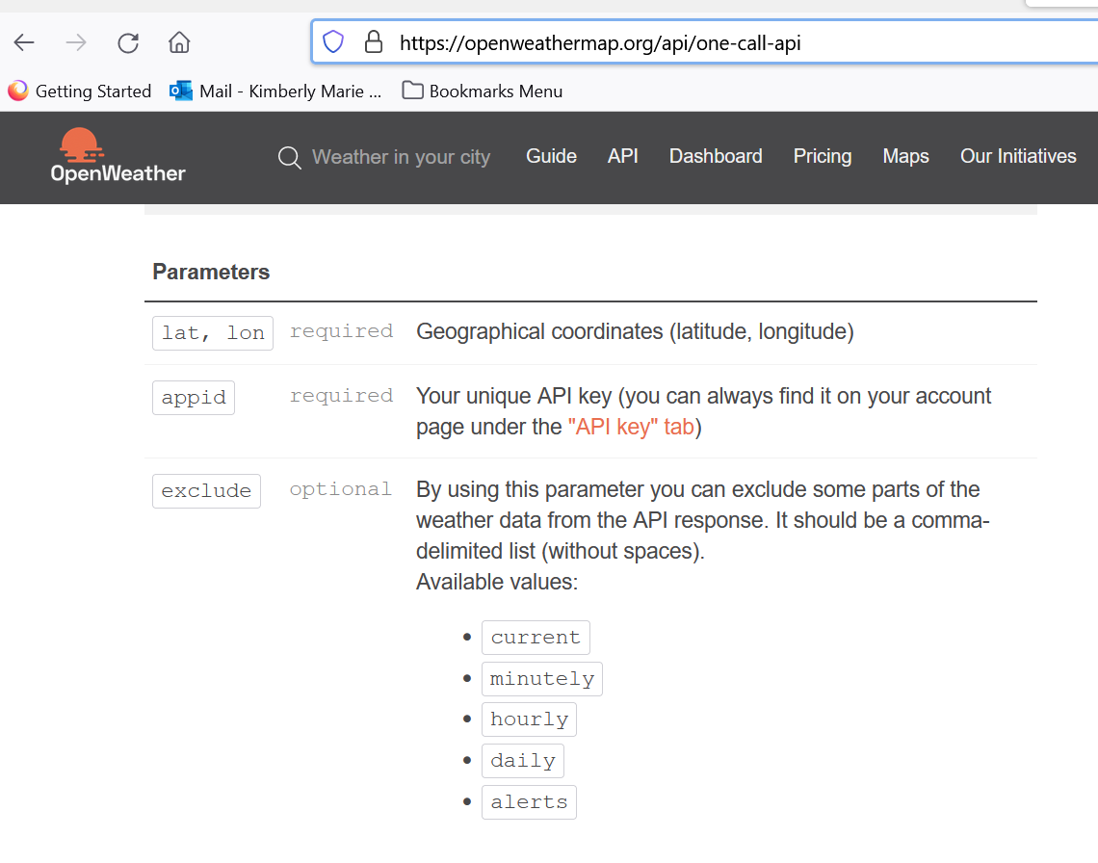

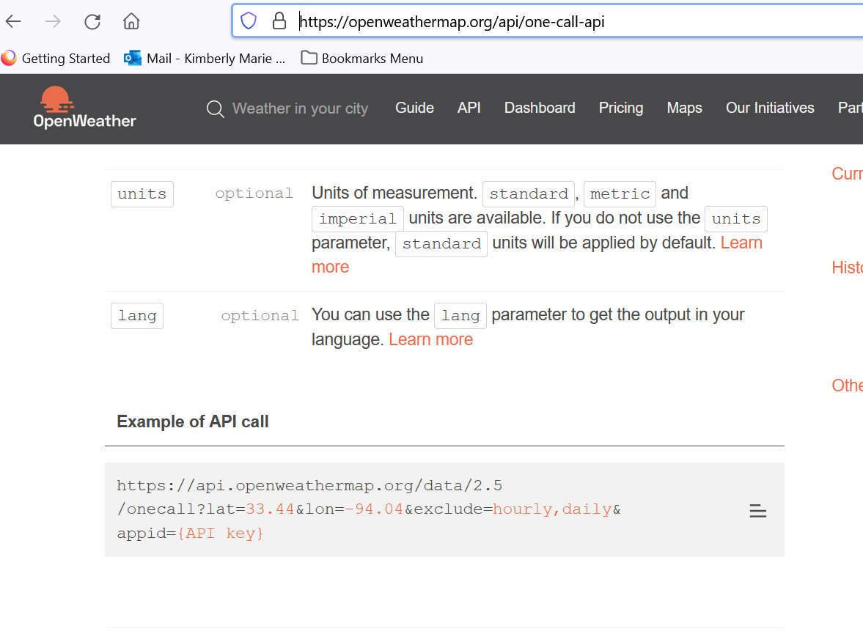

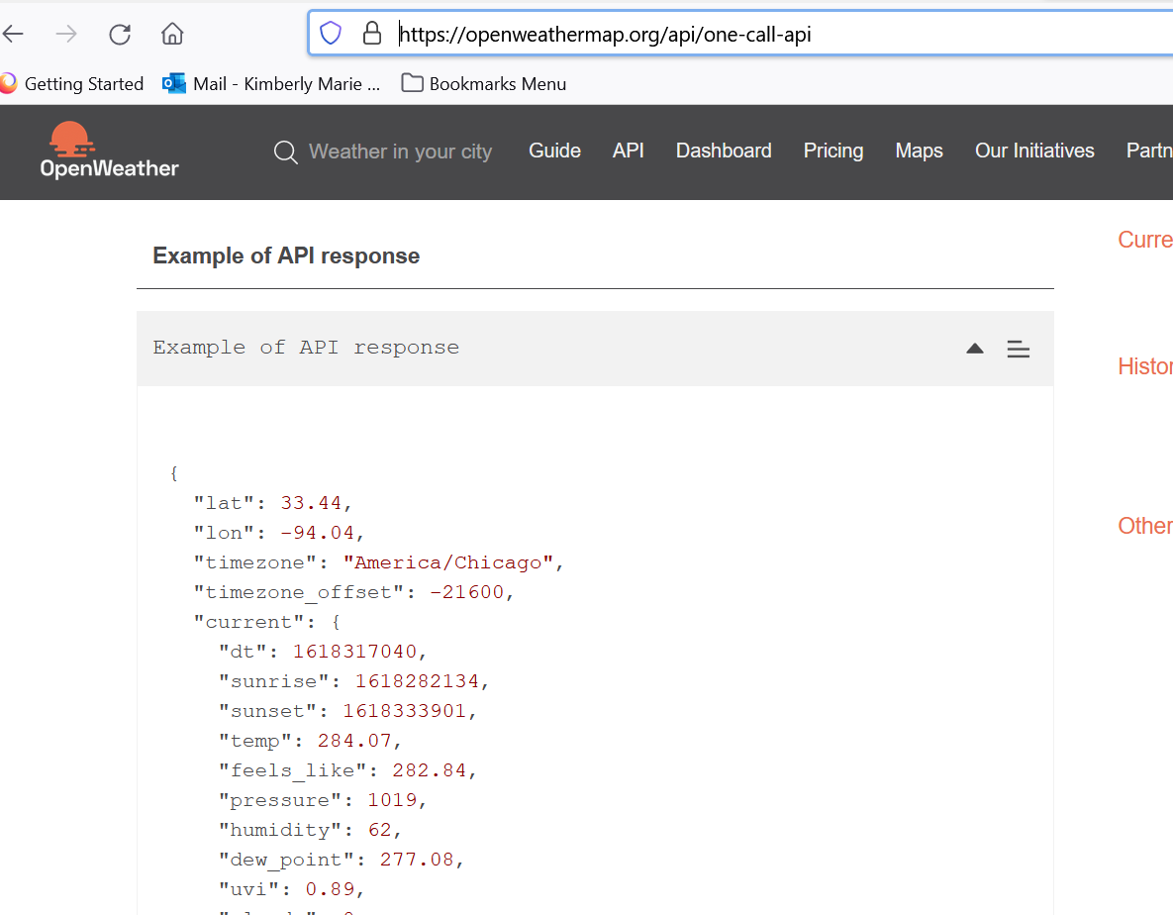

Fields in API response

* lat Geographical coordinates of the location (latitude)
* lon Geographical coordinates of the location (longitude)
* timezone Timezone name for the requested location
* timezone_offset Shift in seconds from UTC
* current **Current weather data API response**
* current.dt Current time, Unix, UTC
* current.sunrise Sunrise time, Unix, UTC
* current.sunset Sunset time, Unix, UTC
* current.temp Temperature. Units - default: kelvin, metric: Celsius, imperial: Fahrenheit. [How to change units used](https://openweathermap.org/api/one-call-api#data)
* current.feels_like Temperature. This temperature parameter accounts for the human perception of weather. Units – default: kelvin, metric: Celsius, imperial: Fahrenheit.
* current.pressure Atmospheric pressure on the sea level, hPa
* current.humidity Humidity, %
* current.dew_point Atmospheric temperature (varying according to pressure and humidity) below which water droplets begin to condense and dew can form. Units – default: kelvin, metric: Celsius, imperial: Fahrenheit.
* current.clouds Cloudiness, %
* current.uvi Current UV index
* current.visibility Average visibility, metres
* current.wind_speed Wind speed. Wind speed. Units – default: metre/sec, metric: metre/sec, imperial: miles/hour. [How to change units used](https://openweathermap.org/api/one-call-api#data)
* current.wind_gust (where available) Wind gust. Units – default: metre/sec, metric: metre/sec, imperial: miles/hour. [How to change units used](https://openweathermap.org/api/one-call-api#data)
* current.wind_deg Wind direction, degrees (meteorological)
* current.rain
* current.rain.1h (where available) Rain volume for last hour, mm
* current.snow
* current.snow.1h (where available) Snow volume for last hour, mm
* current.weather
* current.weather.id [Weather condition id](https://openweathermap.org/weather-conditions#Weather-Condition-Codes-2)
* current.weather.main Group of weather parameters (Rain, Snow, Extreme etc.)
* current.weather.description Weather condition within the group ([full list of weather conditions](https://openweathermap.org/weather-conditions#Weather-Condition-Codes-2)). Get the output in [your language](https://openweathermap.org/api/one-call-api#multi)
* current.weather.icon Weather icon id. [How to get icons](https://openweathermap.org/weather-conditions#How-to-get-icon-URL)
* minutely **Minute forecast weather data API response**
* minutely.dt Time of the forecasted data, unix, UTC
* minutely.precipitation Precipitation volume, mm
* hourly **Hourly forecast weather data API response**
* hourly.dt Time of the forecasted data, Unix, UTC
* hourly.temp Temperature. Units – default: kelvin, metric: Celsius, imperial: Fahrenheit. [How to change units used](https://openweathermap.org/api/one-call-api#data)
* hourly.feels_like Temperature. This accounts for the human perception of weather. Units – default: kelvin, metric: Celsius, imperial: Fahrenheit.
* hourly.pressure Atmospheric pressure on the sea level, hPa
* hourly.humidity Humidity, %
* hourly.dew_point Atmospheric temperature (varying according to pressure and humidity) below which water droplets begin to condense and dew can form. Units – default: kelvin, metric: Celsius, imperial: Fahrenheit.
* hourly.uvi UV index
* hourly.clouds Cloudiness, %
* hourly.visibility Average visibility, metres
* hourly.wind_speed Wind speed. Units – default: metre/sec, metric: metre/sec, imperial: miles/hour.[How to change units used](https://openweathermap.org/api/one-call-api#data)
* hourly.wind_gust (where available) Wind gust. Units – default: metre/sec, metric: metre/sec, imperial: miles/hour. [How to change units used](https://openweathermap.org/api/one-call-api#data)
* chourly.wind_deg Wind direction, degrees (meteorological)
* hourly.pop Probability of precipitation
* hourly.rain
* hourly.rain.1h (where available) Rain volume for last hour, mm
* hourly.snow
* hourly.snow.1h (where available) Snow volume for last hour, mm
* hourly.weather
* hourly.weather.id [Weather condition id](https://openweathermap.org/weather-conditions#Weather-Condition-Codes-2)
* hourly.weather.main Group of weather parameters (Rain, Snow, Extreme etc.)
* hourly.weather.description Weather condition within the group ([full list of weather conditions](https://openweathermap.org/weather-conditions#Weather-Condition-Codes-2)). Get the output in [your language](https://openweathermap.org/api/one-call-api#multi)
* hourly.weather.icon Weather icon id. [How to get icons](https://openweathermap.org/weather-conditions#How-to-get-icon-URL)
* daily **Daily forecast weather data API response**
* daily.dt Time of the forecasted data, Unix, UTC
* daily.sunrise Sunrise time, Unix, UTC
* daily.sunset Sunset time, Unix, UTC
* daily.moonrise The time of when the moon rises for this day, Unix, UTC
* daily.moonset The time of when the moon sets for this day, Unix, UTC
* daily.moon_phase Moon phase. 0 and 1 are 'new moon', 0.25 is 'first quarter moon', 0.5 is 'full moon' and 0.75 is 'last quarter moon'. The periods in between are called 'waxing crescent', 'waxing gibous', 'waning gibous', and 'waning crescent', respectively.
* daily.temp Units – default: kelvin, metric: Celsius, imperial: Fahrenheit. [How to change units used](https://openweathermap.org/api/one-call-api#data)
* daily.temp.morn Morning temperature.
* daily.temp.day Day temperature.
* daily.temp.eve Evening temperature.
* daily.temp.night Night temperature.
* daily.temp.min Min daily temperature.
* daily.temp.max Max daily temperature.
* daily.feels_like This accounts for the human perception of weather. Units – default: kelvin, metric: Celsius, imperial: Fahrenheit. [How to change units used](https://openweathermap.org/api/one-call-api#data)
* daily.feels_like.morn Morning temperature.
* daily.feels_like.day Day temperature.
* daily.feels_like.eve Evening temperature.
* daily.feels_like.night Night temperature.
* daily.pressure Atmospheric pressure on the sea level, hPa
* daily.humidity Humidity, %
* daily.dew_point Atmospheric temperature (varying according to pressure and humidity) below which water droplets begin to condense and dew can form. Units – default: kelvin, metric: Celsius, imperial: Fahrenheit.
* daily.wind_speed Wind speed. Units – default: metre/sec, metric: metre/sec, imperial: miles/hour. [How to change units used](https://openweathermap.org/api/one-call-api#data)
* daily.wind_gust (where available) Wind gust. Units – default: metre/sec, metric: metre/sec, imperial: miles/hour. [How to change units used](https://openweathermap.org/api/one-call-api#data)
* daily.wind_deg Wind direction, degrees (meteorological)
* daily.clouds Cloudiness, %
* daily.uvi The maximum value of UV index for the day
* daily.pop Probability of precipitation
* daily.rain (where available) Precipitation volume, mm
* daily.snow (where available) Snow volume, mm
* daily.weather
* daily.weather.id [Weather condition id](https://openweathermap.org/weather-conditions#Weather-Condition-Codes-2)
* daily.weather.main Group of weather parameters (Rain, Snow, Extreme etc.)
* daily.weather.description Weather condition within the group ([full list of weather conditions](https://openweathermap.org/weather-conditions#Weather-Condition-Codes-2)). Get the output in [your language](https://openweathermap.org/api/one-call-api#multi)
* daily.weather.icon Weather icon id. [How to get icons](https://openweathermap.org/weather-conditions#How-to-get-icon-URL)
* alerts **National weather alerts data from major national weather warning systems**
* alerts.sender_name Name of the alert source. Please read here the [full list of alert sources](https://openweathermap.org/api/one-call-api#listsource)
* alerts.event Alert event name
* alerts.start Date and time of the start of the alert, Unix, UTC
* alerts.end Date and time of the end of the alert, Unix, UTC
* alerts.description Description of the alert
* alerts.tags Type of severe weather

National weather alerts are provided in English by default.   
Please note that some agencies provide the alert’s description only in a local language.

List of weather condition codes

List of [weather condition codes](https://openweathermap.org/weather-conditions) with icons (range of thunderstorm, drizzle, rain, snow, clouds, atmosphere including extreme conditions like tornado, hurricane etc.)

Other features

Units of measurement

standard, metric and imperial units are available.

[List of all API parameters with available units.](http://openweathermap.org/weather-data)

API call

[http://api.openweathermap.org/data/2.5/onecall?lat={lat}&lon={lon}&units={units](http://api.openweathermap.org/data/2.5/onecall?lat=%7blat%7d&lon=%7blon%7d&units=%7bunits)}

|  |  |  |
| --- | --- | --- |
| **Parameters** | | |
| units | optional | Units of measurement. standard, metric and imperial units are available. If you do not use the units parameter, standard units will be applied by default. |

Temperature is available in Fahrenheit, Celsius and Kelvin units.

Wind speed is available in miles/hour and meter/sec.

* For temperature in Fahrenheit and wind speed in miles/hour, use units=imperial
* For temperature in Celsius and wind speed in meter/sec, use units=metric
* Temperature in Kelvin and wind speed in meter/sec is used by default, so there is no need to use the units parameter in the API call if you want this

Examples of API calls

Standard (default)

api.openweathermap.org/data/2.5/onecall?lat=30.489772&lon=-99.771335

Metric

api.openweathermap.org/data/2.5/onecall?lat=30.489772&lon=-99.771335&units=metric

Imperial

api.openweathermap.org/data/2.5/onecall?lat=30.489772&lon=-99.771335&units=imperial

<https://openweathermap.org/price>

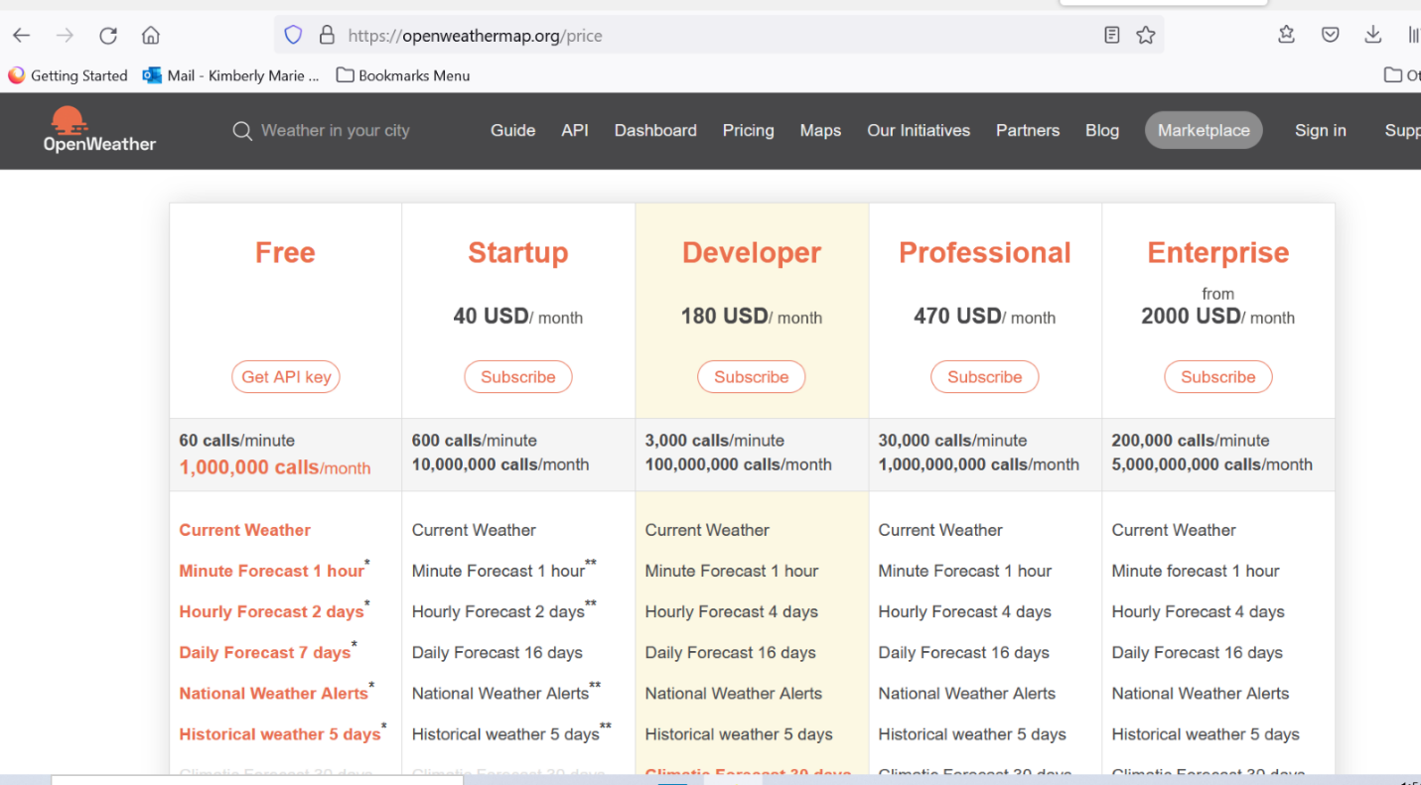

<https://openweathermap.org/technology>

Why our Free Weather API is so good yet free

Such powerful technologies as our ML can significantly advance both the accuracy and computing speed of global assemble forecasting models, a practice that was impossible only a few years ago. That makes the entire calculation fast and cost-effective, providing millions of customers with accurate forecasts promptly.

Weather data should be open to anyone

Not many types of data can affect business decisions and personal everyday plans on the same scale as weather data does. And that is not to mention the billions of dollars that businesses and governments are losing indeed due to extreme weather conditions that are beyond their control. However, most applications of accurate forecasts and history for businesses are more routine, yet more practical for daily analysis and decision-making. To name just a few, these include analysis of the impact of weather on customers’ demand for retailers, planning of safe routes for transport companies, accurate evaluation of customers’ cases for insurers, sensitive planning of energy consumption for householders, and timely watering of crops for farmers.

Modern technologies make accurate weather data not only widely available, but also nearly free

What seemed impossible just a few years ago, you can now do at lightning speed. Machine learning (ML), neural networks, big data, cloud spaces – all of this is easily accessible for calculating hugely sophisticated forecasting models such as Numerical Weather Prediction (NWP) or short-term forecasts that update rapidly.

ML empowers the classic forecasting models

When it comes to the computing and valuation of complex hydro-meteorological models, we rely on the most honourable agencies such as NOAA, Met Office, ECMWF, Environmental Canada. But we can enhance their models with our knowledge of data science and ML, given that most of the mathematics behind forecasting is well-known. For example, the forecasting algorithms for its extreme form, nowcast, have been in use since the 1950s’ radar data is open, and even free for some territories. Additionally, there are lots of specialised instruments for developers, such as Python libraries for the STEP (Short-term Ensemble Prediction System) computation.

Plethora of open weather data to be fed the ML model

Fortunately, global meteorological companies such as NOAA, the Met Office, Environment Canada and ECMWF share our belief that weather data should be open. They supply us with enormous data feeds, including data from radars, weather satellites and weather stations. They also provide a lot of more specialised products such as road alerts, road risks and marine weather.

**List of Open Weather weather condition names in response under main and description**

<https://openweathermap.org/weather-conditions#Weather-Condition-Codes-2>

**Unix UTC internet explanation – used in daily:dt field for Open Weather**

<https://kb.narrative.io/what-is-unix-time>

**Convert epoch to human-readable date and vice versa**

<https://www.epochconverter.com/>

**Convert Unix time to datetime: fromtimestamp()**

<https://note.nkmk.me/en/python-unix-time-datetime/>

**Open Weather Response in JSON**

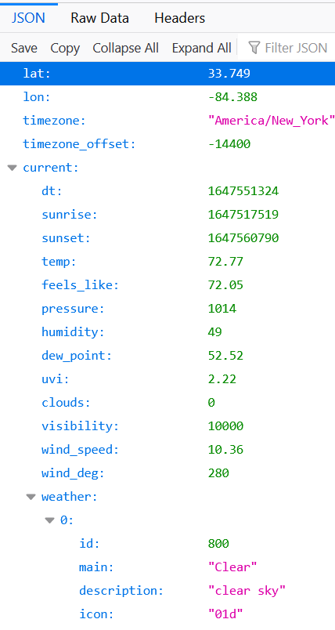

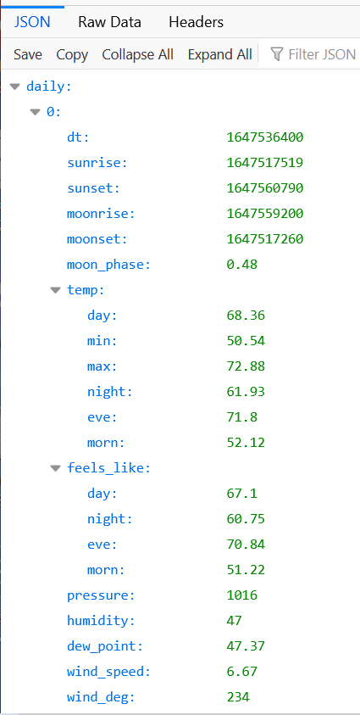

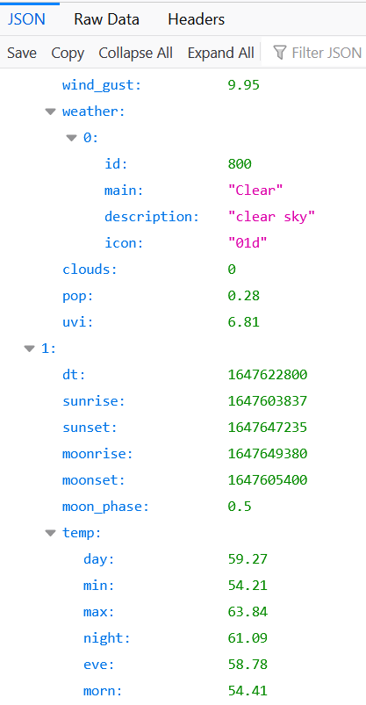

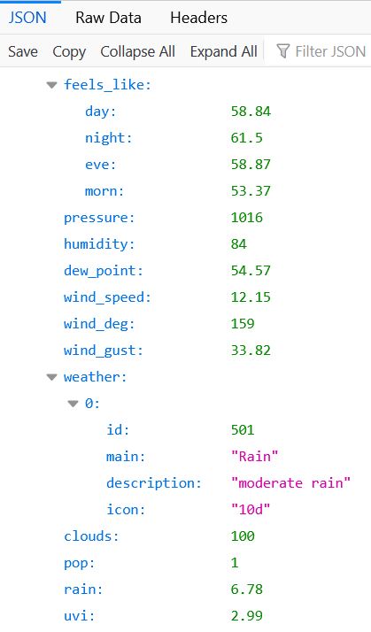

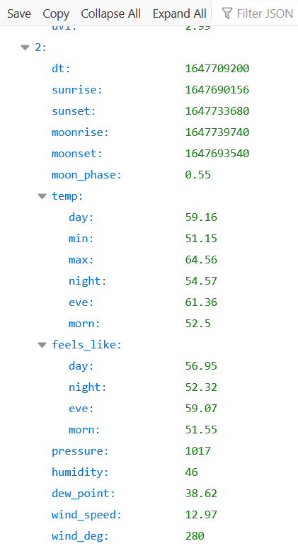

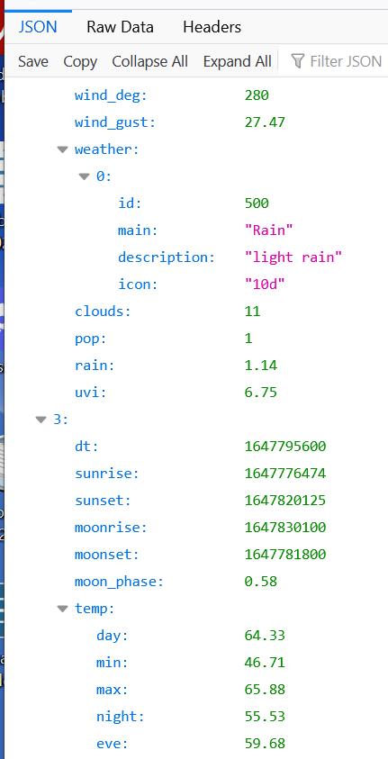

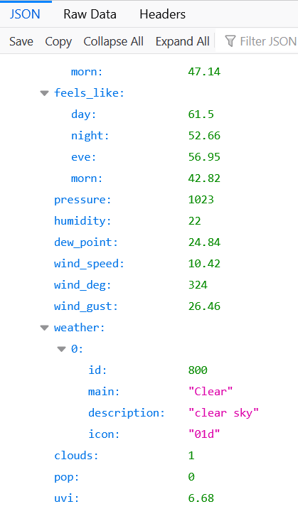

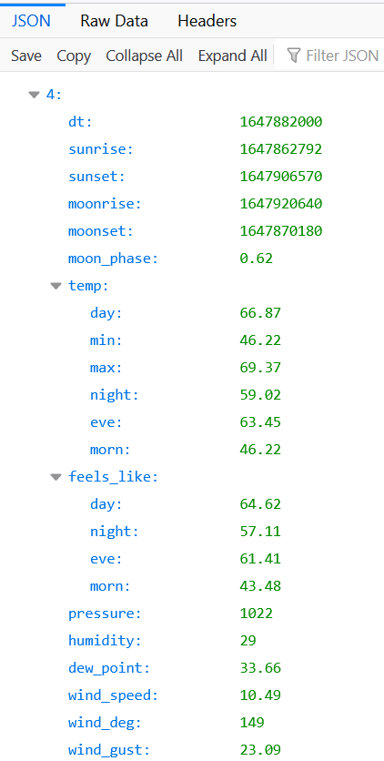

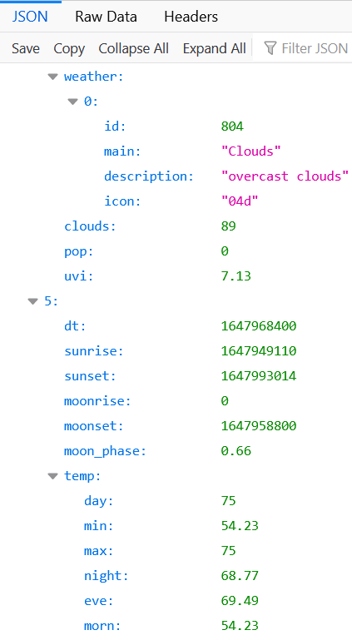

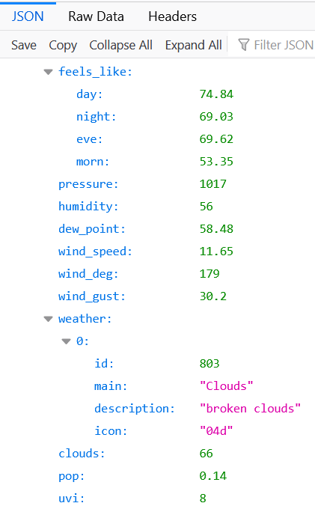

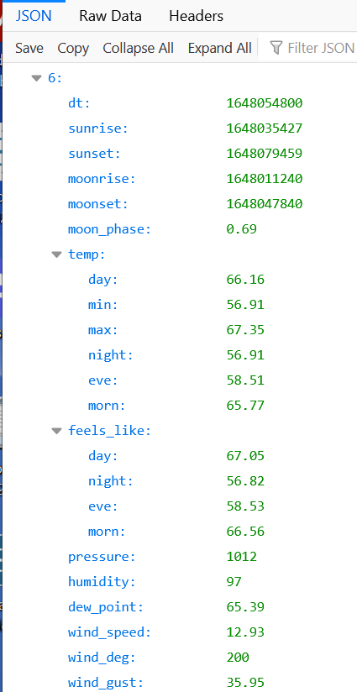

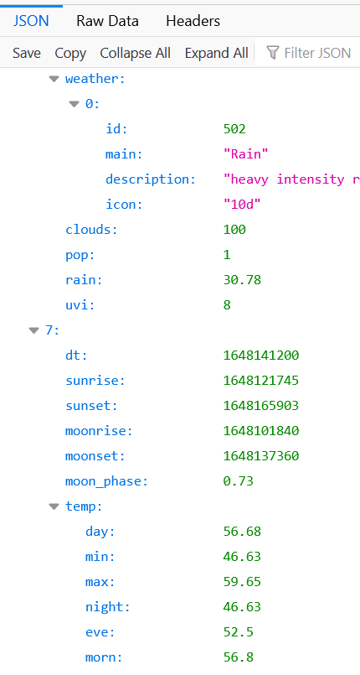

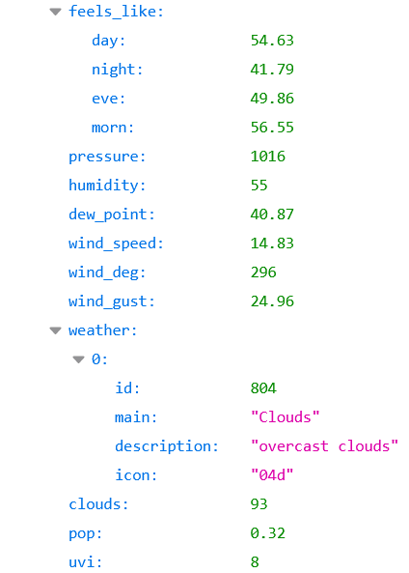

**Holiday csv**

near_weekend_holiday_dates.csv

Contains dates surrounding holidays and weekends which may have higher volume for certain airports.

This information is displayed in the Tableau Dashboard for each airport.

